ISO/IEC JTC 1/SC 24/WG 8 N0648

ISO/IEC JTC 1/SC 24/WG 8
(Environmental Data Representation)
WG 8 Meeting 36
Held On-line due to the COVID-19 Pandemic
3/4 and 10/11 August 2020

Part of the SC 24 Meetings
Held during 27/28 July – 17/18 August 2020

WG 8 Meeting Plan and Agenda

Meeting Logistics and Registration
As a result of the ISO letter dated 2020-06-05 concerning the holding of meetings during the COVID 19 (Coronavirus) pandemic (see Annex A), the face-to-face SC 24 Plenary meetings that would have taken place in Melbourne Fl., USA during 27-31 July 2020, will now be held as a series of web-meetings over the period 27/28 July to 17/18 August 2020.
Each of the on-line meetings is scheduled for 2 hours and will be accessible from all time zones. Connection information (via Zoom URLs) will be provided in July.
SC 24 Meeting Dates
Monday/Tuesday 27/28 July – Monday/Tuesday 17/18 August 2020
SC 24 Meeting Plan
The JTC 1/SC 24 meeting plan for all WG and SC 24 meetings is provided in Annex B of this document. The agenda for the WG 8 meetings are given in this document.
Registration
Registration of meeting attendees is required via the ISO online system at: https://sd.iso.org/meetings/66349 for WG 8.
Registration for other meetings is also possible by selecting ‘My Meetings’ in the left hand column.

If you are unable to use the online system, please email the Secretary (Charles.whitlock@bsigroup.com).

SC 24 Meeting Plan
A number of changes to the SC 24 Meeting Plan (Annex B) have been necessary to avoid extending the meeting period beyond the current 3 weeks. In particular, a full day of presentations from SC 24, WGs and Study Groups that would normally be held at the start of the week, has been omitted. However, it is still possible that a technical presentation may be added to the schedule.

The following meetings are directly related to WG 8.
For local times, refer to Annex B.

WG 8 Working Session:
Monday/Tuesday 3/4 August

WG 8 Plenary:
Monday/Tuesday 10/11 August

SC 24 Plenary:
Monday/Tuesday 17/18 August

WG 8 Environmental Data Representation
On-line Working Session 2020
Agenda

Monday/Tuesday 3/4 August 2020
07:00 – 09:00 Tuesday 4 August: Australia (East Coast)
06:00 – 08:00 Tuesday 4 August: Japan
06:00 – 08:00 Tuesday 4 August: Korea
05:00 – 07:00 Tuesday 4 August: Beijing (China Standard Time)
23:00 – 01:00 Monday/Tuesday 3/4 August: France
22:00 – 23:59 Monday 3 August: UK
17:00 – 19:00 Monday 3 August: USA (East Coast)
14:00 – 16:00 Monday 3 August: USA (Pacific)

Connection information (via Zoom URLs) will be provided in July.

Chair: Jack Cogman
- Welcome and Introductions
- ISO Code of Conduct at Meetings
- Current and Anticipated Work Plan:
3.1 18041-5 EDCS LB to C++
3.2 18042-5 SRM LB to C++
3.3 18024-5 SEDRIS Part 1 LB to C++
- Proposal for an XML-based format for SEDRIS (Myeong Won Lee)
- Update on SISO RIEDP Products and Standards (Farid Mamaghani)
- SISO EDRS Product Support Group (Paul Foley)
- NGA Plans for Spatial Referencing (Craig Rollins)
- EDCS Registry
- SC 24 Road Map
- Current status of Action Items
- Review of the planned WG 8 work programme
- Draft recommendations to be forwarded to the WG 8 Plenary meeting

Back to Top
WG 8 Environmental Data Representation
On-line Plenary Meeting 2020
36th Plenary Agenda

Monday/Tuesday 10/11 August 2020
07:00 – 09:00 Tuesday 11 August: Australia (East Coast)
06:00 – 08:00 Tuesday 11 August: Japan
06:00 – 08:00 Tuesday 11 August: Korea
05:00 – 07:00 Tuesday 11 August: Beijing (China Standard Time)
23:00 – 01:00 Monday/Tuesday 10/11 August: France
22:00 – 23:59 Monday 10 August: UK
17:00 – 19:00 Monday 10 August: USA (East Coast)
14:00 – 16:00 Monday 10 August: USA (Pacific)

Connection information (via Zoom URLs) will be provided in July.

Chair: Jack Cogman
- Welcome and introductions
- ISO Code of Conduct at Meetings
- Approval of the minutes of the 35th meeting held at Takamatsu, Japan 2019
- Convenor's report
- Summary of key topics from the Working Session
- National Body reports
- Liaison reports
- SEDRIS
- SISO
- Any other liaison reports
- Editors reports
- Reports and Appointment of registry rapporteurs
- EDCS
- SRM
- SEDRIS
- Summary of WG 8 content in the draft SC 24 Business Plan for 2020-21
- Work Schedule
- Review and approval of WG 8 Recommendations to SC 24
- Review action items
- Adjourn
Back to Top
Annex A

Sergio Mujica  Secretary-General | TO CEOs OF ISO MEMBERS, STANDARDS DIRECTORS, CHAIRS, COMMITTEE MANAGERS AND CONVENORS
COVID-19
2020-06-05

INFORMATION REGARDING ISO GOVERNANCE AND TECHNICAL MEETINGS – EXTENSION OF MEASURES TO 30 SEPTEMBER 2020

Dear Members,

Following my letter dated 8 May 2020, regarding the measures in place for ISO governance and technical meetings during the COVID-19 crisis, I would like to inform you that it has been decided, with the support of the ISO President’s Committee, that the measures be extended to 30 September 2020, whereby all meetings must be held virtually or postponed until after this date.

The extension of these measures will continue to be reviewed and communicated on a monthly basis.

I would like to reiterate that these decisions are taken based on safeguarding the health and wellbeing of people in the ISO community, to ensure the business continuity of our Organization, and provide certainty and clear guidance to the community regarding meetings that have been planned for the upcoming months. Detailed guidance in order to implement this decision is available from https://connect.iso.org/x/fZVHCw. The ISO Council and Technical Management Board (TMB) have been duly informed. The TMB will update their exceptional policy measures accordingly.

I also take this opportunity to update you that ISO/CS staff continue to telework, remaining available to support ISO members and the technical community, and will do so until further notice.

Best regards,

Sergio Mujica

Cc. President Vice-President (policy)
Vice-President (technical management)
Vice-President (finance)
Treasurer

Back to Top

Annex B

SC 24 Plenary On-line Meeting Plan - 2020

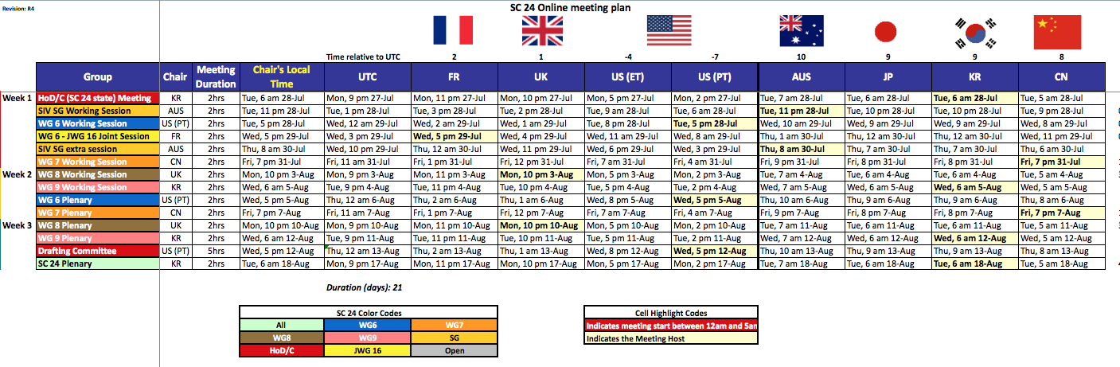

Back to Top

