ISO/IEC JTC 1/SC 24/WG 8 N0638

ISO/IEC JTC 1/SC 24/WG 8
(Environmental Data Representation)
WG 8 Meeting 35
Takamatsu-shi, Kagawa, Japan
26 – 30 August 2019

WG 8 Meetings and Agenda

Meeting Logistics and Registration

The 2019 SC 24 Plenary and Working Group meetings will be held on 26-30 August at:
Sunport Hall Takamatsu,
2-1 Sunport,
Takamatsu-shi, Kagawa-ken 760-0019,
Japan
The calling notice for the SC 24 meetings is given in document SC 24 N4205.
The logistics details are given in document SC 24 N4208, including a map of the area near the venue.
As some WG 8 members may not be able to travel, web conferencing facilities are being provided to allow such members to participate in the meetings via web/phone.

Local Organizer
The meeting has been organized by Masaki Aono, Takeshi Kurata, ITSCJ and JISC
There will not be a meeting fee.
Meeting Dates
Monday 26 August – Friday 30 August 2019
Meeting Plan
The JTC 1/SC 24 meeting plan for all WG and SC 24 meetings is provided in Annex 1 of this document. The agenda for the WG 8 meetings are given in this document.
Registration
Registration of SC 24 meeting attendees is now compulsory via the ISO online system: https://sd.iso.org/meetings/59904. Please register at the ISO web site no later than 10 August 2019 for all your SC 24 meetings. If you are unable to use the online system, please email the Secretary (Charles.whitlock@bsigroup.com).
Persons participating only by web/phone do not need to register, but should inform the WG 8 Convenor by email (jack.cogman@datasim.net) of their plan to participate remotely.

Meeting Plan
The following meetings are relevant to WG 8. All times are local to Takamatsu:

Technical Presentations:
Monday 26 August 2019
08:30 – 17:30

WG 8 Working Session:
Wednesday, 28 August 2019
08:30 – 12:00

WG 8 Plenary:
Thursday, 29 August 2019
08:30 – 10:00

The SC 24 Plenary:
Friday, 30 August 2019
0830 – 13:00

WG 8 members are also encouraged to attend the following meetings:
- WG 6 Plenary – 13:00 – 14:30 Wednesday, 28 August
- WG 7 Plenary – 14:30 – 16:00 Wednesday, 28 August
- WG 9 Plenary – 10:30 – 12:00 Thursday, 29 August
- JWG 16 Working Session – 10:30 – 12:00 Thursday, 29 August
- JWG 16 Plenary – 13:00 – 14:00 Thursday, 29 August

In addition, the following meetings are relevant to WG 8, but unfortunately overlap with WG 8 meetings:
- SG Systems Integration Visualization – 10:30 – 12:00 Wednesday 28 August
- JWG 16 Working Session – 08:30 – 10:00 Wednesday, 28 August
- JWG 16 Working Session – 08:30 – 10:00 Thursday, 29 August

The timetable for all meetings held in Takamatsu is given in Annex A.

WG 8 Environmental Data Representation
Takamatsu, Japan - 2019

Working Session Agenda

Wednesday, 28 August 2019
0830 – 1200 Takamatsu, Japan
These times correspond to:
09:30 – 13:00 Australia (East Coast)
07:30 – 11:00 Beijing (China Standard Time)
01:30 – 05:00 France
00:30 – 04:00 UK
19:30 – 23:00 Tuesday USA (East Coast)
16:30 – 20:00 Tuesday USA (Pacific)
Chair: Jack Cogman
- Welcome and Introductions
- Current Work Schedule
- Pending and Planned Work Programmes:
In view of the ISO rule that a WG with no items on its Work Programme should be disbanded, it is important for a new work item to be requested. The following NWIPs are proposed:
EDCS LB to C++
SEDRIS LB to C++
- EDCS Registry
- SISO RIEDP project on Reuse and Interoperation of Environmental Data and Processes
- Study Group on Systems Integration Visualization
- SC 24 Road Map
- Relevant Presentations not shown on Monday
- Current status of Action Items
- Review of the planned WG 8 work programme
- Draft recommendations to be forwarded to the WG 8 Plenary meeting

Back to Top

WG 8 Environmental Data Representation
Takamatsu, Japan - 2019

35th Plenary Agenda
Thursday, 29 August 2019
08.30 – 1000 Takamatsu, Japan
These times correspond to:
09:30 – 11:00 Australia (East Coast)
07:30 – 09:00 Beijing (China Standard Time)
01:30 – 03:00 France
00:30 – 02:00 UK
19:30 – 21:00 Tuesday USA (East Coast)
16:30 – 18:00 Tuesday USA (Pacific)
Chair: Jack Cogman
- Welcome
- Roll call and introductions
- Corrections to, and approval of, the minutes of the 34th meeting held at OKTAL-SE, Toulouse, France
- Convenor's report
- Summary of key topics from the Working Session
- National Body reports
- Liaison reports
- SEDRIS
- SISO
- Any other liaison reports
- Editor reports
- Reports from the registry rapporteurs
- Appointment of registry rapporteurs
- EDCS
- SRM
- SEDRIS
- Summary of WG 8 content in the draft SC 24 Business Plan for 2019-20
- Work Schedule
- Review and approval of WG 8 Recommendations to SC 24
- Review action items
- Adjourn

Annex A

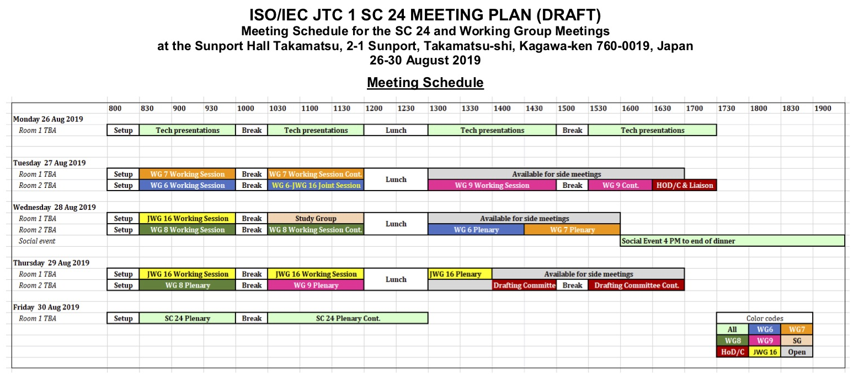

Back to Top

